# Combating Misinformation and Hate Crimes

Human beings have this infinite capacity of achieving monumental things. As the centuries have passed , we observe that the rate of innovation and us advancing as civilization has been almost exponential. It is interesting that the basic instincts wired is our brains haven’t gone through much advancements like Fight or Flight ,

Love and Attachment, Hunger and Thirst, Self-Preservation, Curiosity and Exploration, Reproduction and Procreation, Social Hierarchies, Aggression and Defence. But their purpose has been interleaved as time has passed.

In the light of how these basic instincts are used by our brains when we are no longer cavemen, we need to understand how misinformation is spread building ideologies which leads to hate crimes and killings in the community

But first we need to understand how ideologies spread for people to have opinion and to act on.

Networks rule the world. From chemical reactions to food chains it is networks in the society which shape the course of events. Consider following examples

* Infectious diseases jumping from host to host within a population
* Memes spreading across a follower graph on social media
* A wildfire breaking out across a landscape
* Ideas and practices diffusing through a culture
* Neutrons cascading through uranium atoms

It turns out that there's a *precise* tipping point that separates **subcritical networks** (tends to extinction) from **supercritical networks** (capable of never ending growth). This tipping point is called the **critical threshold**. This is where spreading hate crimes and misinformation have to be monitored and such value is subjective to the kind of application. there's an academic cottage industry devoted to finding these critical thresholds for different network topologies (the concept being called ‘percolation threshold’).

If in the network, some nodes are resistant or “immune” to activation (for instant spreading information) . These are what stabilizes a chain reaction in the coming. Changing the number of immune nodes in a community alters whether hate crimes spread widely or remain contained. With more immune nodes, each incident has fewer chances to spread. This has implications for preventing hate crime outbreaks, similar to containing wildfires with firebreaks.

Achieving societal immunity against hate crimes, relies on enough of the community opposing hate. Implementing measures like promoting inclusivity and swiftly addressing discrimination acts as immune nodes, mitigating hate spread.

Effectively combating hate crimes requires maintaining balance, similar to controlling a nuclear reaction. It involves promoting tolerance along with swiftly addressing instances of hate, preventing its widespread escalation.

Social connections play the most crucial role in the life of individual and society. People look to their social connections to understand their world. People may get wrong ideas about society because they are in that infected connection. This is explained by **majority illusion** . This is what makes susceptible people think that their opinion / hate is justified. This madness -spreading is called as “information cascade”. Naturally “fact spreading” can too be cascading. We need such mindsets and right willed individuals to participate more.

"Unity without uniformity". "Diversity without division" out of many, No matter how it's phrased, people across times and cultures often arrive at the same piece of wisdom i.e society needs a sweet spot of bonds within groups and bridges between groups to decrese hatred.

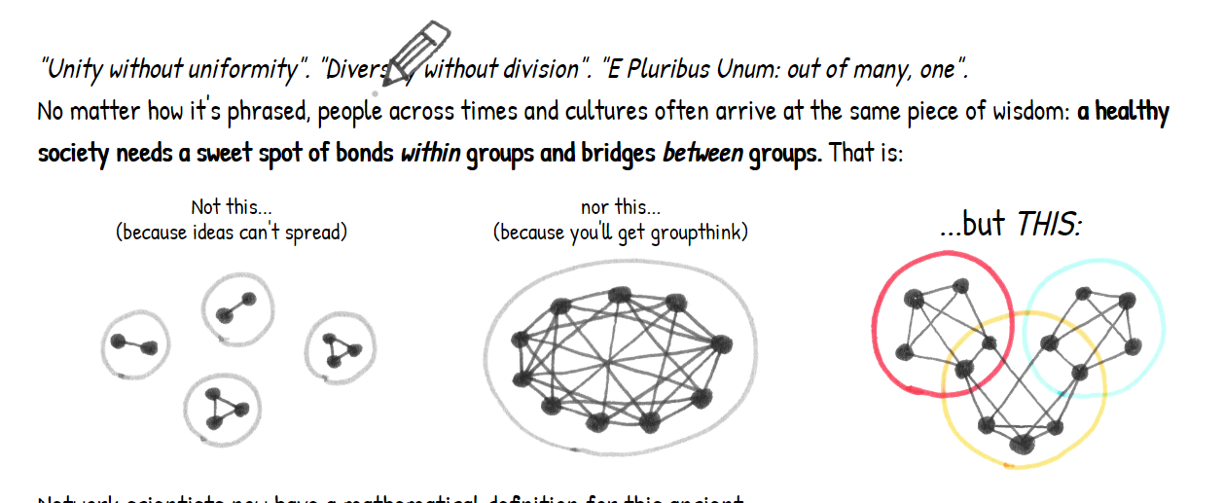

So what can be our step towards decreasing cascade of mis information and violence?

We need to understand that the madness of crowds isnot necessarily caused by some individual, but because of how we are trapped in a web of interleaved beliefs. Since we are the ones making up these netwrksit is our individual responsibliy to be mindful, to be skeptical of the new booming ideals , to spend time understanding its effects in the long run. To consciously allow connections, bonding stronger with similar people along with building bridges across cultural/ political divides to increase our perspective.

It is about standing on our own grounds firm and repecting thesurroundings too.



“we become what we behold”  
  
Tools that we shape for dispersing ‘knowledge’ are the ones shaping the health of the world network.

Media be it newspapers, books or news channels have had the most deep impact on the social network.

As much as we need to keep up with the ongoing scenarios, it is up to the narration of the content on how it translates through the crowd.

Citizens along with the government have to be the part of policies that govern the quality of journalism, as blunt as it should be , it must not be the reason for hatred. The truth, the neutral narration is all e need.

As nations with independent policies and judiciary , what can we learn from the ones which have got it right in terms of crime rate.

1. Iceland: Strong Social Safety Net Iceland consistently ranks at or near the top of the safest countries in the world. One factor contributing to this is Iceland's comprehensive social safety net. This system provides financial assistance to those who are unemployed, sick, or disabled. This helps to reduce poverty and inequality, which are often linked to crime.

Iceland landscape

pen_spark

1. Singapore: Strict Law Enforcement and Zero-Tolerance Policy Singapore is well known for its strict laws and zero-tolerance approach to crime. Vandalism, littering, and even jaywalking can result in hefty fines or even jail time. Singapore also has very strict gun control laws. These policies have helped to create a safe and orderly society.

Singapore city

1. Japan: Emphasis on Social Harmony and Community Policing Japanese culture places a strong emphasis on social harmony and respect for authority. This helps to create a society where people are less likely to commit crimes. Japan also has a well-funded and well-trained police force that focuses on community policing.

Japan city

1. Denmark: Universal Healthcare and Education Denmark, like other Nordic countries, has a strong social safety net that includes universal healthcare and education. This helps to ensure that everyone has access to the basic necessities of life, which can help to reduce crime.

Denmark landscape

1. Switzerland: Decentralized Government and Direct Democracy Switzerland has a decentralized government system that gives a great deal of power to local communities. This allows communities to tailor crime prevention strategies to their specific needs. Switzerland also has a strong tradition of direct democracy, which allows citizens to participate directly in making decisions about their communities.

Switzerland mountains

1. New Zealand: Focus on Restorative Justice and Community Engagement New Zealand has a justice system that focuses on restorative justice, which aims to rehabilitate offenders rather than simply punish them. New Zealand also has a strong emphasis on community engagement in crime prevention.